Problem Statement:
Using the Molecular Dynamics Lattice Model, this work simulates protein folding and unfolding in continuous space, emphasizing GPU utilization with CUDA for enhanced inter-residue force calculations. A CPU-based simulation analyzes a short 10-residue sequence, considering temperature fluctuations, kinetic and potential energy, and the simulation's runtime.

Algorithm explanation and dynamics
A Nosé-Hoover-like thermostat regulates a synthetic protein sequence, alternating between hydrophobic and polar residues at 300 K, employing the Velocity Verlet integration method to compute forces and total energies. Key factors such as system balance, radius of gyration, and expected position/velocity influence convergence speed. The algorithm's objectives are to determine
- Temperature and
- Energy.
Dynamics of Temperature Calculation
The average kinetic energy of particles is represented by temperature in Molecular Dynamics (MD). This is derived from statistical mechanics' Equipartition Theorem.
This theorem says that each squared term in a particle's total energy adds 0.5 * k_{B} * T to the average energy. Where k_{B} = Boltzmann constant, and T = absolute temperature.
In molecular dynamics system:
- Degrees of Freedom: This is a 3D simulation where each particle can move in three directions (x, y, z). According to the kinetic energy formula (0.5*m*(vx² + vy² + vz²)), a system of N atoms can move in 3N total ways as each particle has three ways to move.
- Center of Mass Constraint: To prevent drifting, the system's center of mass movement is frequently eliminated in MD simulations. This eliminates three degrees of freedom, reducing the number of ways to calculate energy to 3N-3.
- Temperature and Total Kinetic Energy Relationship:
  - According to the equipartition theorem, the total average kinetic energy (KEtotal) of a system is calculated as KEtotal = dof*(0.5*k_{B}*T), where T can be derived as T = (2*KE_{total})/(dof*k_{B}).
Purpose: In molecular dynamics (MD) simulations, a predetermined target temperature is often set to replicate specific thermodynamic conditions, such as in the NVT ensemble. A thermostat adjusts particle velocities to ensure that the system's current temperature, based on its kinetic energy, matches this target, thereby preserving stable experimental conditions in the simulation.

Energy Calculation

Dynamics
There are 2 types of energy here: Potential and Kinetic energy.
Total Energy = Kinetic + Potential Energy
- Potential Energy (PE) depends on the locations of the particles (and how they interact).
- Kinetic Energy (KE) depends on the speeds of the particles.
- The locations and speeds are updated using Velocity Verlet Integration using forces - bonded and non-bonded.

Potential Energy
Energy Potential In order to influence potential and kinetic energy changes, it is crucial for simulations to convert potential energy functions into forces. For bonded particles, forces include spring-like interactions; for non-bonded particles, they include attractive and repulsive interactions. The mathematical expression for force is F = -∇V, indicating that the goal of forces is to reduce the potential energy of a system.
Force’s Dynamics
This is essential because it illustrates the interactions between each atom in the protein.

Harmonic bonds, or bonded interactions:
By controlling the distances between atoms, covalent bonds in proteins act like springs to preserve structural integrity. Atoms are drawn together when they are too far apart (r > r₀) and pushed apart when they are too close (r < r₀). This behavior is described by a harmonic potential formula V = k * (r - r₀)², where r is the atom distance, r₀ is the normal bond length, and k is the spring constant.

Angle Bending Interactions:
These forces maintain the proper bond angles between three residues that are linked. Here, the force acts on the center atom of the three according to its distance from θ₀. As a result, the bonds' directions change.
Formula: Formula: The angle θ between two linked bonds is used to calculate a harmonic potential. The ideal angle is denoted by θ₀, and the angle bending constant is denoted by kangle.

Lennard-Jones Potential, Non-Bonded Interactions: The Lennard-Jones potential controls how non-bonded atoms interact to form hydrophobic cores and shape proteins. In this model, r is the interatomic distance, epsilon represents the strength of the interaction, and sigma represents the size of the atom. Residue types have different interaction strengths: proline-proline (epsilon = 0.3) reduces attraction, hydrogen-hydrogen (epsilon = 2.0) increases attraction, and hydrogen-proline (epsilon = 0.8) exhibits moderate attraction. Protein movements are simulated with the aid of these calculated forces.
The Kinetic Energy Kinetic energy is directly related to and determined by speeds (and mass). KE = 0.5*mass*velocity² is the relationship.

Kinetic Energy
Speeds (and mass) are directly tied to and used to find kinetic energy. The relationship:
- KE = 0.5*mass*velocity².
So, for each particle in the simulation, its kinetic energy comes from its mass and the square of its speed. A particle's kinetic energy increases with speed. Kinetic energy is thus the energy of motion.
Forces Cause Acceleration (Newton's Second Law): The simulation applies Newton's second law (F = ma) after forces have been determined.
Acceleration Modifies Velocity: Acceleration is the rate at which velocity changes. A particle's velocity will alter over a time step (dt) if it experiences a force.
Kinetic energy is defined as KE = 0.5*mass*velocity². Changing velocity results in changing kinetic energy. A particle's kinetic energy is directly altered when its velocity is changed.

Purpose:
- The idea is to see how different molecules and atoms interact and affect each other.
- It provides a means of measuring motion and aids in understanding stability. This is important and useful in drug design, etc.

CPU Implementation (Molecular Dynamics Simulator):
The algorithm above takes O(N²) time.
Using NumPy, the CPU configuration generates the fundamental dynamics and physics.
Numpy for math A is one of the libraries used.

A. Molecular Interactions: Determine potential energy and forces
The total force calculation has three terms:
- Bonded Forces (Harmonic Spring): The chain is linked between nearby residues (i and i+1).
- Angle Bending Forces:Adds stiffness to the polymer chain, acting over three residues (i, i+1, i+2).
- Non-Bonded Forces (Lennard-Jones): This takes the most time since it has O(N²) pairwise interactions between all non-nearby residues (j > i+1).
HP Model Specificity: The interaction strength (epsilon) depends on the residue types:
- Hydrophobic-Hydrophobic (H-H): Strongest attraction, epsilon = 2.0, which causes folding.
- Polar-Polar (P-P): Weak repulsion, epsilon = 0.3.
- Hydrophobic-Polar (H-P): Medium interaction, epsilon = 0.8.
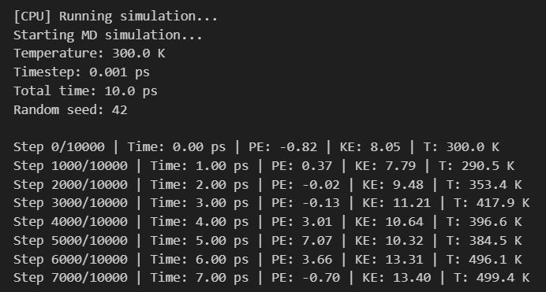
The number of computed interactions is limited by a cutoff distance of 20.0 Angstroms..

The Challenges of CPU Configuration
Determining the forces between every pair of atoms (non-bonded interactions) is the primary step in simulating molecules, such as proteins or DNA.
- Physics: We compute two non-bonded forces:
- Van der Waals (VDW) Forces: These are short-range forces that cause atoms to weakly attract one another when they are at the proper distance and to repel one another when they are too close.
- Long-range forces between charged atoms are known as electrostatic forces (Coulomb's Law).
- The computation It is necessary to compute the interaction between each pair of atoms in a system of N atoms. This computation is N *times (N-1)/2, or roughly O(N²).
- The Problem: For a protein with N=100,000 atoms, N² is 10 billion calculations, which is too slow for real-time views or long MD simulations.

GPU Implementation and Optimization ( MDCUDASimulator)
The GPU setup, using the MDCudaSimulator class, changes the core MD calculations into optimized Numba CUDA kernels. This makes use of the GPU architecture's multitasking capabilities.

Integration of Kernel-Based Velocity Verlet
Direct kernels are used for simple, highly parallel operations like position and velocity updates:
- The two components of the Velocity Verlet integration are handled by separate kernels that update positions and velocities concurrently. They use a factor calculation to lower extra math in the kernel.
- Zero forces kernel resets quickly for the force array for the next step.

Force Calculation Optimization
- Bonded and Angle Forces: all N-1 and N-2 bonds and angles are subjected to parallel execution of calculate_bonded_forces_kernel and calculate_angle_forces_kernel.
- Critical Optimization: Since a single atom is affected by two different threads (one for the i bond and one for the i+1 bond), the kernel uses cuda.atomic.add to safely add forces on shared atoms. This stops race conditions and is important for correctness in parallel force calculations.
Utilizing CUDA Concepts
- Coalesced Memory Access: When threads with close indices process nearby points in the positions array, efficient coalesced memory access is achieved. This increases memory bandwidth by allowing 32 threads to read 32 memory locations at once.
- Sequential Access Pattern: The cuda.grid(1) setup, which pushes sequential data access among threads, demonstrates how working on particles in order enables the GPU's L1/L2 caches to prefetch data for later threads.
- Register-Based Accumulation: To speed up calculations, the force pieces fx, fy, and fz are located in each thread, stored in fast registers, and then added to the global forces array using atomic operations.
- The bottleneck, or non-bonded forces: The calculate_nonbonded_forces_tiled_kernel has undergone the largest modification.
- Tiling and Shared Memory: To compute the O(N2) interactions, the kernel employs a tiled method that makes use of shared memory (tile pos, tile seq).
Instead of getting data from slow global memory for coordinates, chunks of positions (size TILE SIZE = 32) are put into fast shared memory.
Using the information in shared memory, threads in a block iterate through every tile and compute pairwise forces. This reduces global memory access latency and brings data closer together.
Each thread adds forces for the atom it controls (i) across all interacting tiles using local accumulators (fx_{i}, fy_{i}, and fz_{i}). Until the outcome is written back to global memory, this reduces conflict and the need for atomic operations.
- Shared Memory Tiling: Particles are added to cuda.shared.array (tile_pos, tile_seq) once for each tile and then used again in the computation of the block.
- Coalesced Memory Access: Positions[j_load, :], where j_load = tile_start + tid, is used to store data in shared memory, enabling threads to access nearby memory.
- Minimal Atomic Operations: At the conclusion of tile processing, forces for the i-th particle are written atomically to global memory after being added in registers (fx_{i}, fy_{i}, fz_{i}).

The Cutoff Radius (A Parallel Trick)
The GPU's task is to speed up this O(N2) computation. First, let's simplify:
- Concept (Spatial Locality): Short-range electrostatic forces and VDW forces rapidly decrease with distance. The force becomes negligible beyond a certain distance (the cutoff radius, usually 10–12 Ångströms).
- Action: Instead of checking 100,000 atoms for every atom, only check atoms within a small radius. As a result, there are fewer checks, which simplifies the issue for the GPU.

Calculating Temperature and Energy
The system quickly computes kinetic and potential energies from the GPU by using kernels with a Parallel Sum Reduction kernel.

Conclusion/Observations:
- Even though the GPU implementation was completed solely with the Numba library—no external libraries were used—the performance was still far better than that of the CPU.
- The O(N²) complexity of Non-Bonded Interactions computation primarily affects performance in large systems, where N is the length of the sequence.
- The GPU offers significant speedup, achieving a 700.84x increase for N=500.
- On the other hand, the algorithm's computational demands limit CPU performance, with run times growing quadratically (for example, a sequence that is 50 times longer takes about 1000 times longer to execute for N=500 as compared to N=10).
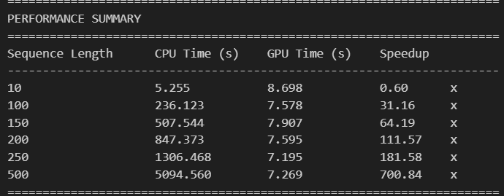

- The attached output demonstrates the low N memory-bound property in GPU processing:
- For extremely small residue sizes (e.g., N=10), the speedup is negative (0.60x).
- It suggests a temporary memory-bound state related to data movement and emphasizes that the overhead from data transfer between the Host and Device, rather than the computation itself, is the primary factor limiting the execution time.
- The GPU implementation uses a tiling technique to address possible memory-bandwidth constraints using efficient memory access patterns.
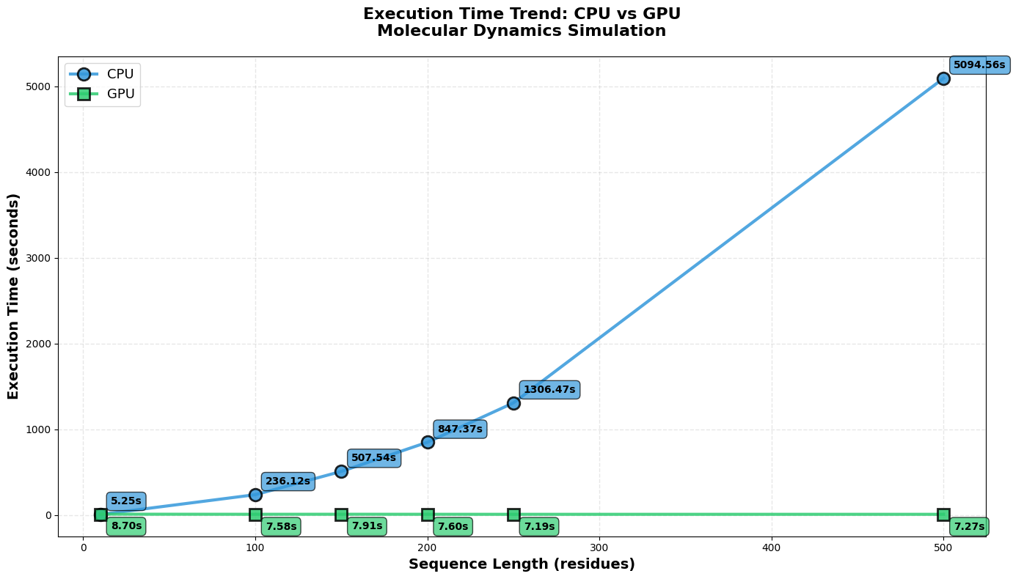
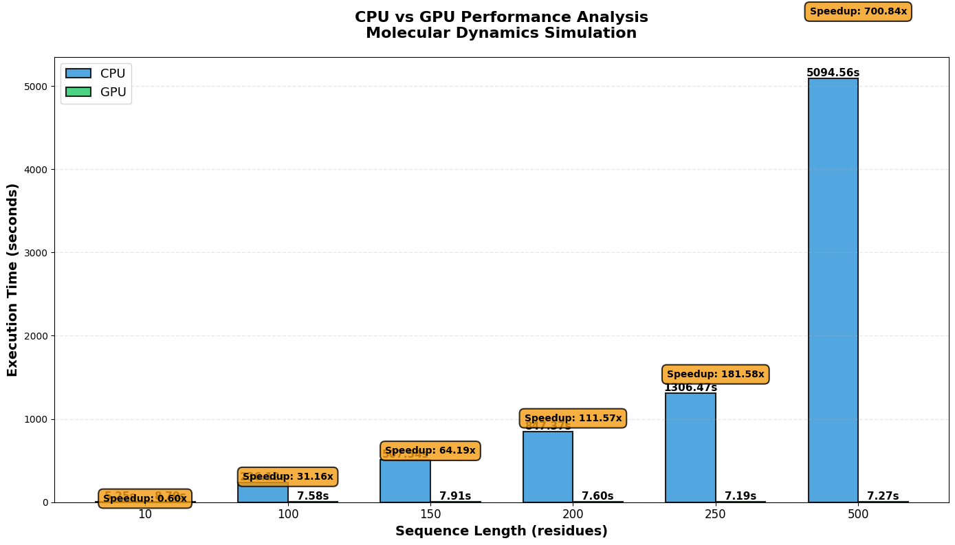
- In order to reduce slow global memory access, the calculate_nonbonded_forces_tiled_kernel uses shared memory to store frequently accessed particle coordinates. In order to ensure high-performance computing where the GPU is compute-limited rather than data-starved, this design pattern reduces internal memory bottlenecks in O(N²) algorithms.

- Cell lists are meant to improve molecular dynamics (MD) simulations, but if
- their overhead outweighs their advantages, they may occasionally lengthen job execution times. Performance comparisons across different job sizes are necessary for systems with few atoms because the setup time for cell lists might not justify the decrease in checked particle pairs.
- It is recommended to assess and possibly increase the reordering interval because frequent reordering of particles is inefficient if their movement is minimal.
- Lastly, it's critical to make sure that the forces and energies computed with the cell list match the outcomes from the prior setup because differences could point to problems with the cell list logic that could negatively impact simulation results.
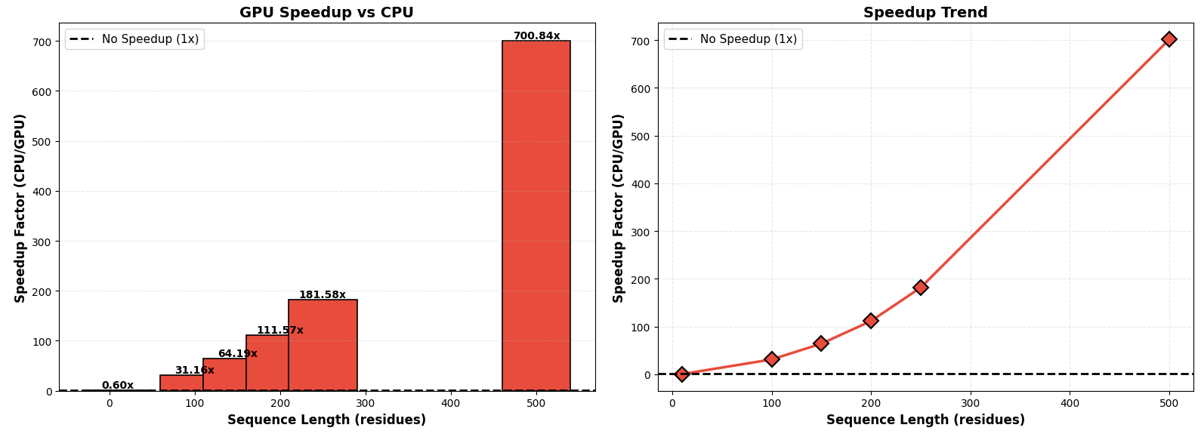
- SpeedUp: The transition from I/O/Memory-Bound to Compute-Bound processes shows a notable increase in speedup, starting at 0.60x for N=10 and rising to over 700x for N=500, as the GPU effectively handles the O(N2) complexity.

- Because the GPU reaches its processing limit around 250 residues, it maintains comparable speeds for sequence lengths of 250 and 500.
- GPUs, which are designed for parallel processing, perform well on smaller tasks by dividing them among cores in an effective manner.
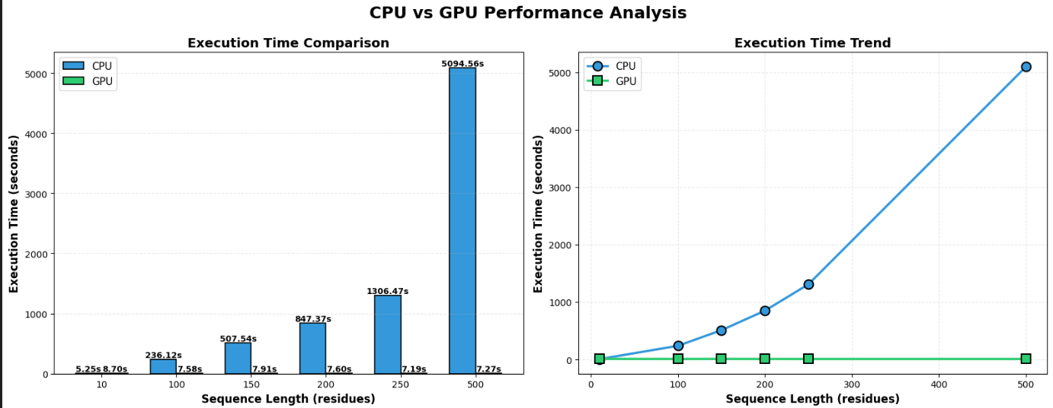
- Nevertheless, the GPU's resources are fully utilized when sequences surpass 200–250 residues, which results in a plateau in performance with no appreciable increase in execution time despite an increased workload.

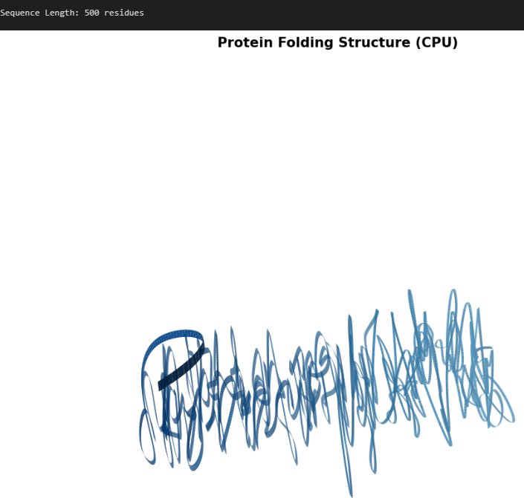
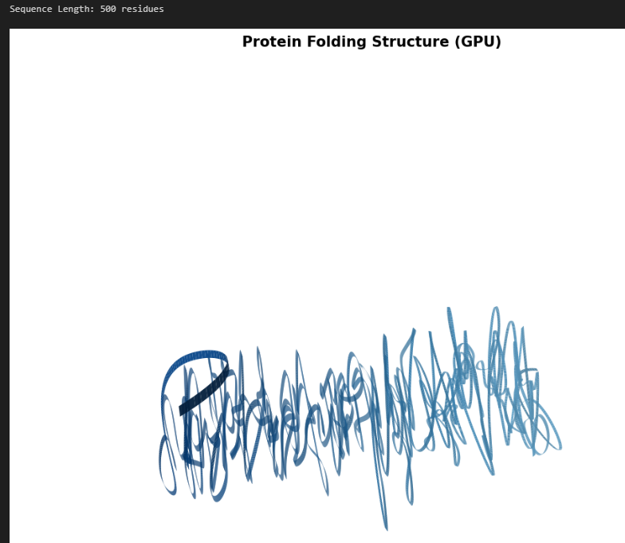
- Comparing the protein structures of GPUs and CPUs This demonstrates that the CPU and GPU yield the same outcomes. 500 residues in a protein folding structure for the CPU and GPU:

